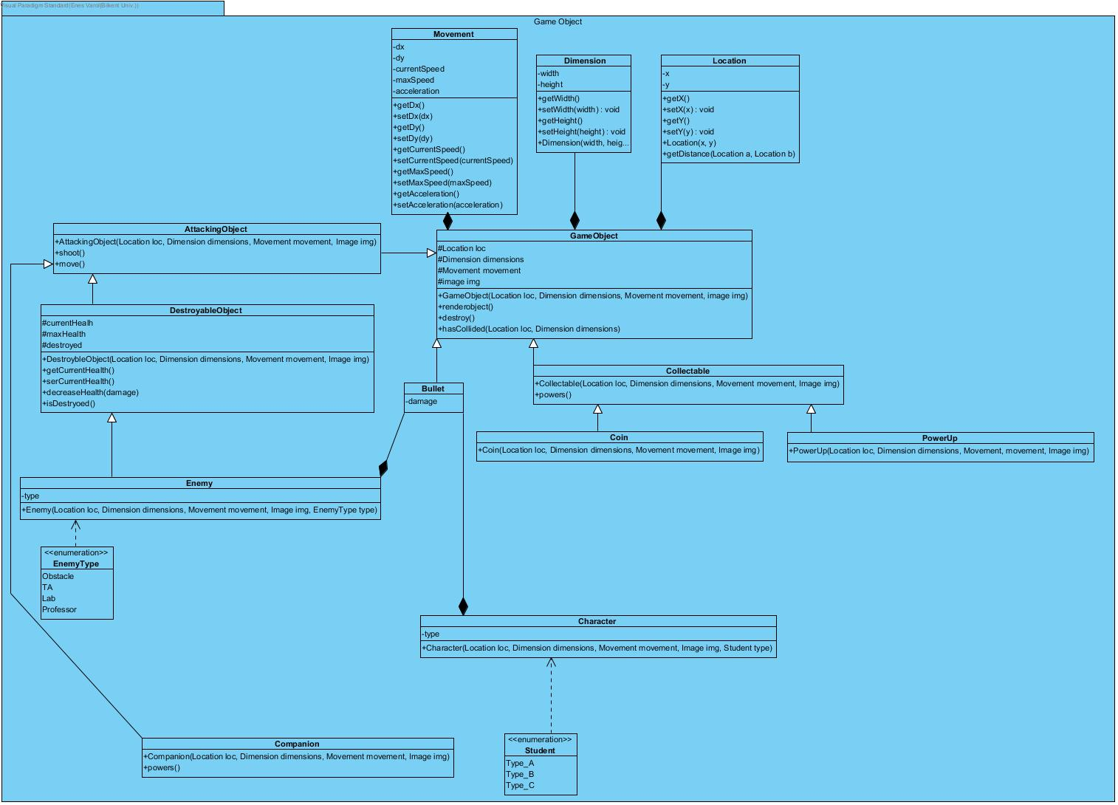

Game Object Subsystem has 12 classes and shows the objects on the screen. The objects of the game are player(student), companions, enemies (Obstacle, Ta, Lab, Professor), Collectables (Coin, Power Up) and bullets. Subsystem holds those objects in classes: Collectable-Coin and Power Up, bullet, Destroyable Object- Enemy, Companion and Character.

Companion not destroyable!

Every object has their own methods to check their status but showing them on the screen is Game Object class’s job, this class shows Objects on the class with its renderobject() method.

GameObject Class

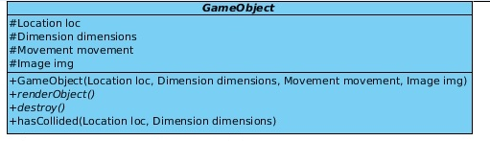

Attributes:

* **private Location loc:**
* **private Dimension dimensions:**
* **private Movement movement:**
* **private Image img:**

Methods:

* **GameObject (Location loc, Dimension dimensions, Movement movement, Image img):**
* **renderObject ():**
* **hasCollided (Location loc, Dimension dimensions):**

Collectable Class



Methods:

* **Collectable (Location loc, Dimension dimensions, Movement movement, Image img)**
* **powers ()**

Coin Class

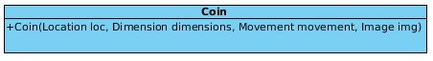

Methods:

* **Coin (Location loc, Dimension dimensions, Movement movement, Image img)**

PowerUp Class



Methods:

* **PowerUp (Location loc, Dimension dimensions, Movement movement, Image img)**

Bullet Class

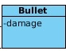

Attributes:

* **Damage**

AttackingObject class

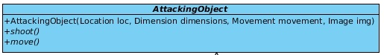

Methods:

* **AttackingObject (Location loc, Dimension dimensions, Movement movement, Image img)**
* **shoot ()**
* **move ()**

DestroyableObject class

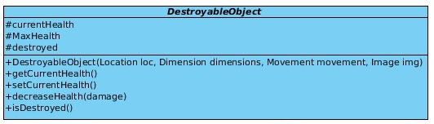

Attributes:

* **currentHealth**
* **Maxhealth**
* **Destroyed**

Methods:

* **DestroyableObject (Location loc, Dimension dimensions, Movement movement, Image img)**
* **getCurrentHealth ()**
* **setCurrentHealth ()**
* **decreaseHealth(damage)**
* **isDestroyed ()**

Enemy Class



Attributes:

* **type**

Methods:

* **Enemy (Location loc, Dimension dimensions, Movement movement, Image img, Enemytype type)**

Character Class

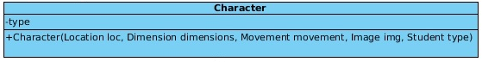

Attributes:

* **type**

Methods:

* **Character (Location loc, Dimension dimensions, Movement movement, Image img, Student type)**

I don’t know what is enumeration

Companion Class

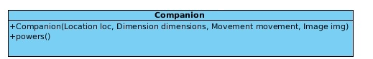

Methods:

* **Companion (Location loc, Dimension dimensions, Movement movement, Image img)**
* **powers ()**

Movement Class

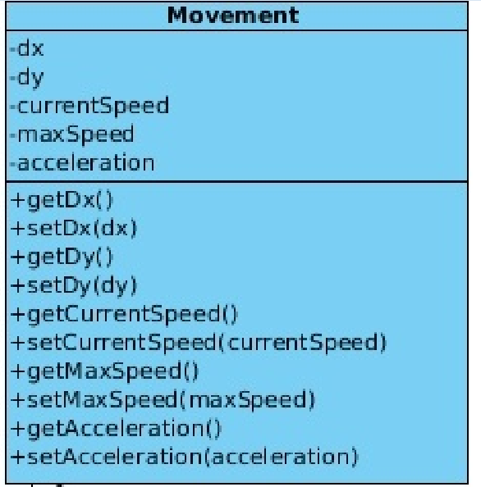

Attributes:

* **dx:**
* **dy:**
* **currentSpeed:**
* **maxSpeed:**
* **acceleration:**

Methods:

* **getDx():**
* **setDx():**
* **getDy():**
* **setDy():**
* **getCurrentSpeed():**
* **setCurrentSpeed(currentSpeed):**
* **getMaxSpeed():**
* **setMaxSpeed(maxSpeed):**
* **getAccelaration():**
* **setAcceleration(acceleration):**

Dimension Class

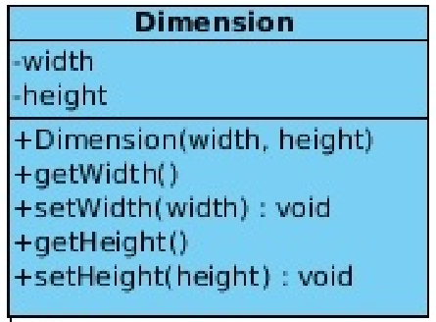

Attributes:

* **width:**
* **height:**

Methods:

* **Dimension(width, height):**
* **getWidth():**
* **setWidth(width):**
* **getHeight():**
* **setHeight(height):**

Location Class

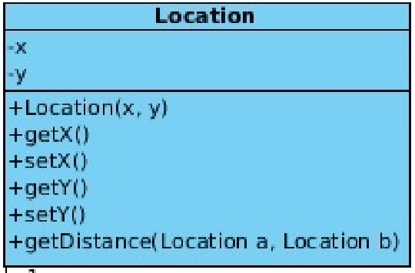

Attributes:

* **x:**
* **y:**

Methods:

* **Location(x,y):**
* **getX():**
* **setX(x):**
* **getY():**
* **setY(x):**
* **getDistance(Location a, Location b):**

THERE ARE ERRORS ON LOCATION AND DIMENSION CLASS!

